Steve & Jeannie Everly Camping
974-146th Ave. Knoxville, Iowa 50139
Jeannie Cell 641-891-9967
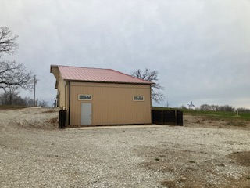
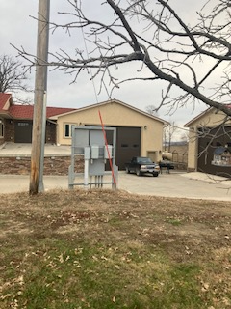
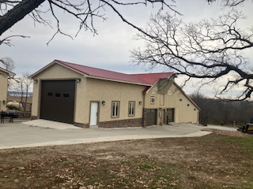

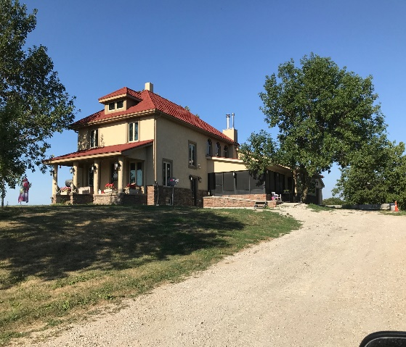
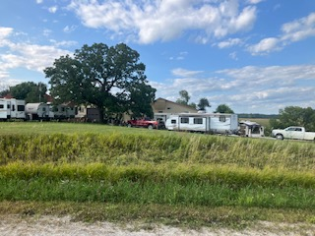

Camper
Camper

Camper
1-50/1-30A
1-20A

Road

Garage
Camper
Parking
Barn
1-50/1-30/1-20
Water

Garage
1-50A 1-30A
Drive
drive
Camper
Camper

Drive
Tree
Power
2-50/2-30/2-20
Garage
1-50 A
Parking
Parking
Tree
Parking
Drive
Drive
Camper
Camper
Camper
Tree
House
974-146th Ave.

